Mental Health Awareness
May is
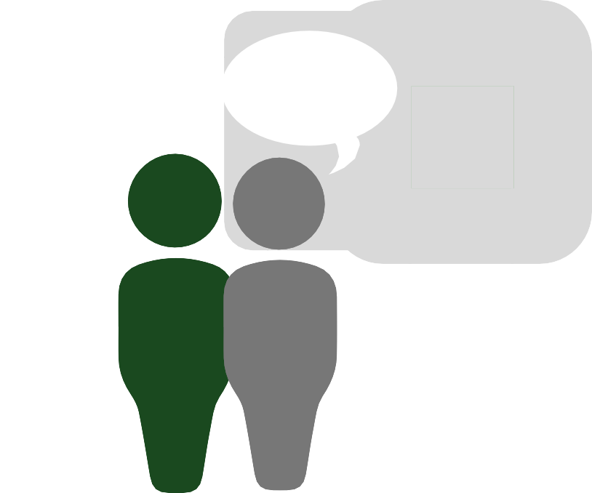Month
Nearly 4 out of 5 Veterans experience symptoms of chronic Posttraumatic Stress Disorder (PTSD) even 20 to 25 years out of service.2

During May, the Seattle ERIC hopes to raise awareness, break down stigma, and provide resources on mental health for Veterans.
Annually, nearly 44 million
adults in the U.S. are diagnosed with mental
1
health conditions.
are
living with mental health conditions.

POSTTRAUMATIC STRESS DISORDER
The rate of PTSD is 15 times higher in Veterans than in civilians. Symptoms include intrusive memories, dissociation, avoidance, feeling numb or guilty, and hypervigilance.3 Free anonymous PTSD screenings are available online at: https://www.myhealth.va.gov/mhv-portal-web/ptsd-screening

BIPOLAR DISORDER
9 million people are diagnosed with bipolar disorder each year. Symptoms include swinging from manic episodes─characterized by impulsive behavior and difficulty focusing, to depressive episodes─characterized by low energy and difficulty remembering things.⁴Helpful resources on bipolar disorder can be found at: www.mentalhealth.va.gov/bipolar.asp

DEPRESSION
The prevalence of depression is 5 times higher in Veterans than in civilians. Symptoms include changes in sleep and appetite, loss of energy and interest, and feelings of hopelessness.⁵Free anonymous depression screenings are available online at: https://www.myhealth.va.gov/mhv-portal-web/depression-screening

QUALITY OF LIFE CAN BE IMPROVED THROUGH A NUMBER OF EFFECTIVE TREATMENTS AVAILABLE FOR THOSE WITH MENTAL HEALTH CONDITIONS.

References:
- https://www.nimh.nih.gov/health/statistics/mental-illness.shtml
- https://www.ncbi.nlm.nih.gov/pmc/articles/PMC2891773/
- https://www.nami.org/NAMI/media/NAMI-Media/Images/FactSheets/PTSD-FS.pdf

- https://www.nami.org/NAMI/media/NAMI-Media/Images/FactSheets/Bipolar-Disorder-FS.pdf
- https://www.nami.org/Find-Support/Veterans-and-Active-Duty

Veterans Crisis Line

SUPPORT IS AVAILABLE 24/7

The Veterans Crisis Line is available through a toll-free number, online chat, or text.
Confidential support is available 24 hours a day, 365 days a year.
Call:
1-800-273-8255 and Press 1 Online: www.VeteransCrisisLine.net Text:
Send Messages to 838255

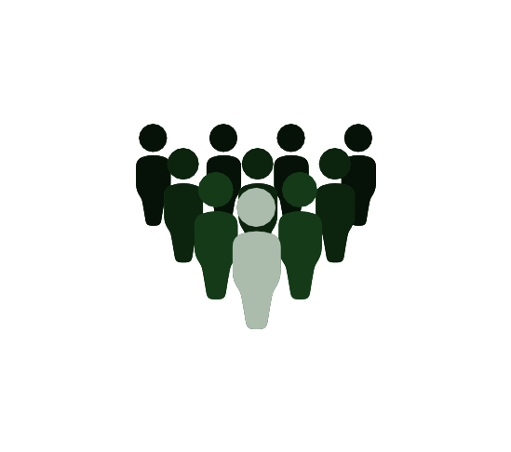ADDITIONAL VETERAN-FOCUSED RESOURCES:
Recovery and self-care can take many
forms. Help can be found through the VA, fellow Veterans, family, friends, and loved ones.
If you are experiencing a medical or mental
emergency, call 911 or go to your nearest hospital.
Make the Connection A Veteran-centered mental health and awareness campaign www.maketheconnection.net
Coaching Into Care A coaching phone line to help talk about concerns and treatment options 888-823-7458 | https://www.mirecc.va.gov/coaching/index.asp
Your VA Talk to your provider or check out the link below to find out how your VA can help you https://www.mentalhealth.va.gov/Resources.asp
Military One Source Military affiliated resource for servicemembers and their families who are looking for mental health services | 1-800-342-9647 | http://www.militaryonesource.mil/web/mos/mental-health

